I have all these sprites downloaded and they’re in a folder.

In the picture above you can see sprites for the torch, sprites for the player itself and sprites for a few enemies. Although I did say about finding a spider so I found a separate sprite which fits the theme below.

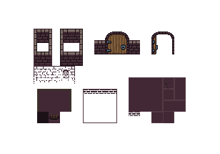

Here is an example of what can be made with this pack.